Instructions for synesthesia battery (to be conveyed over email to participants)
https://synesthete.ircn.jp/home
- Register, do not click ‘I am a researcher’.
- Start new battery
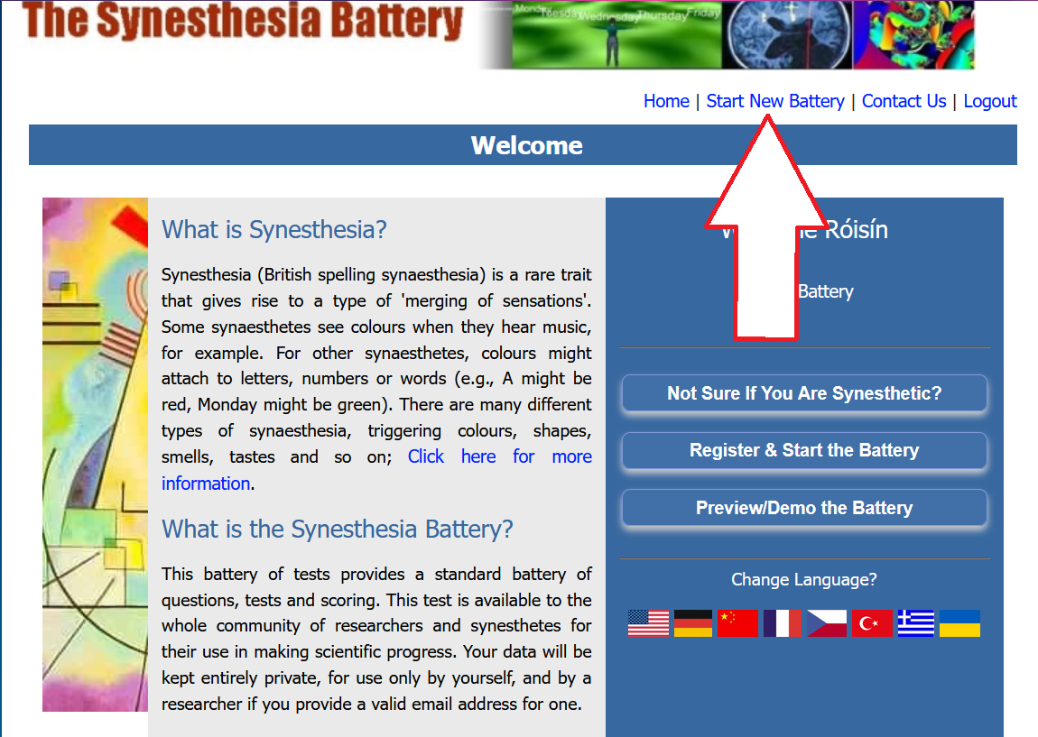
- Enter RS843@sussex.ac.uk as the researcher email
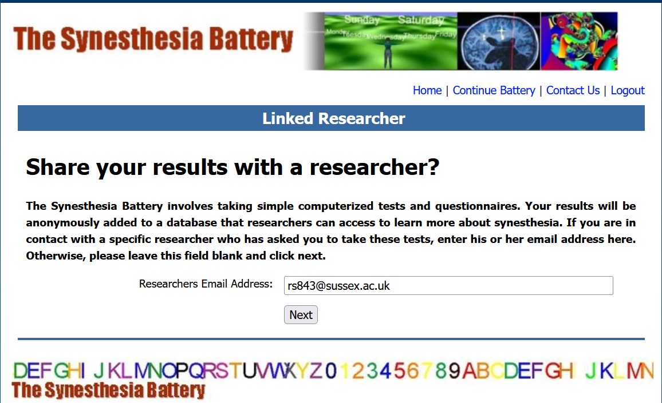4. Read the user agreement and continue if you are happy to.
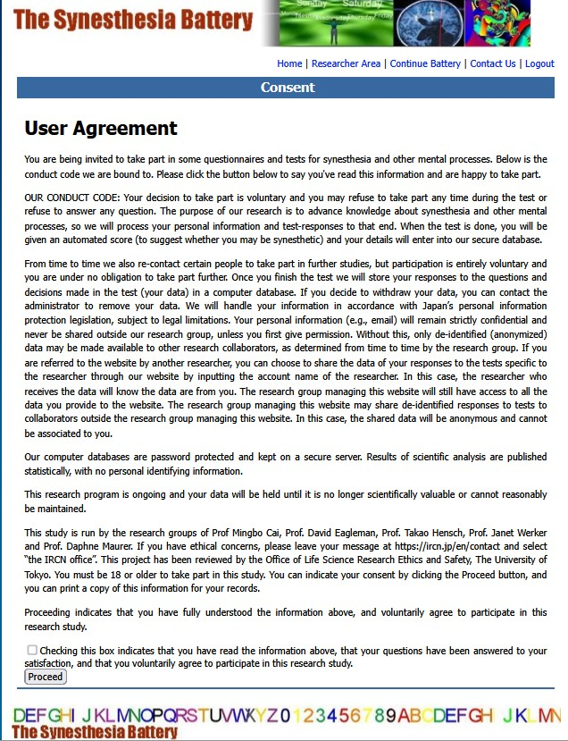
- Enter your type of synesthesia. NOTE: We are only interested in grapheme-colour synesthesia
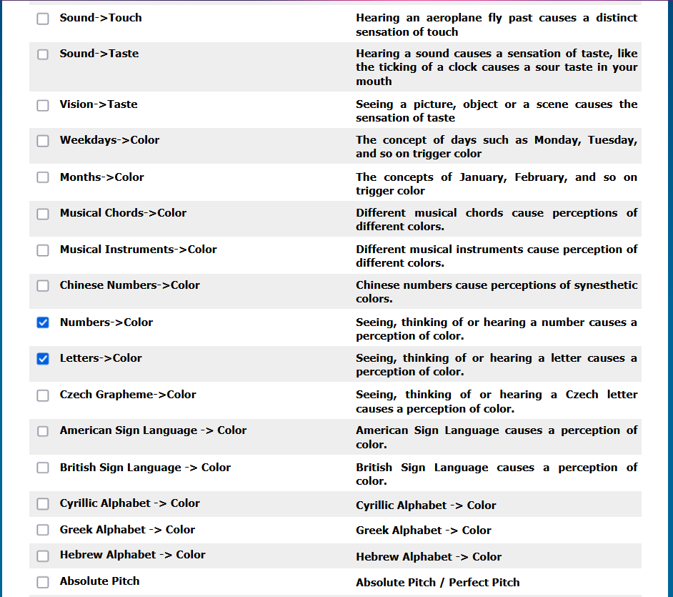5. Fill in the synesthesia questionnaire. Please ensure you answer every question. The questions do not tell you if you’ve accidentally skipped a question, but your results will come up as ‘incomplete’ if any are skipped and the battery will have to be re-taken.
6. After completing the battery, the page tends to error. If you refresh the page, you should see the end of the battery.

